Stojkovic: Desperate people have limited options
STAN STOJKOVIC 5:18 p.m. CDT August 16, 2016, Milwaukee Journal Sentinel

There is never a serious commitment to reducing poverty, addressing income inequality or improving educational opportunities for many urban students.
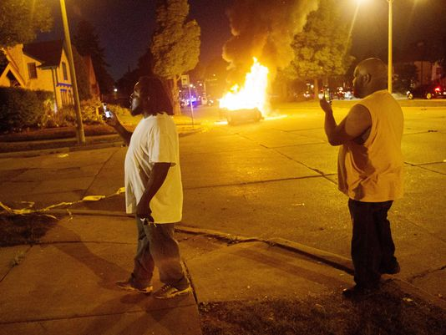
(Photo: Calvin Mattheis/Milwaukee Journal Sentinel via USA TODAY Network)
I was out of town when my brother texted me that “Milwaukee is on fire.” I quickly went online to see if there were any stories describing what was happening. As I collected more information, I recalled something my father said to me 49 years ago back in 1967 when the city experienced an urban riot. I asked him why were people so mad and angry to hurt other people and destroy property and homes. His reply rings true today in the aftermath of the troubles of last Saturday night: “Desperate people have limited options.”
At the age of 11, I never fully understood these words, but I do now. After studying crime and deviance for over 40 years, I know how people respond to perceptions of injustice and abuse when they feel no allegiance to the existing normative code, when their opportunities to live out the American Dream simply do not exist, and when they see their own being harassed, overpoliced and sometimes treated like an animal, or even less than an animal. Violence is the weapon of an impoverished man, paraphrasing Martin Luther King Jr.
Who are the impoverished in Milwaukee? They tend to be young, people of color and male. This does not mean that others are not included in this definition, including young women of color who are raising children. Regarding crime, the same demographic holds true: young, people of color and male are disproportionally arrested by the police, prosecuted by the district attorney’s office, sentenced by the courts and housed by the Department of Corrections. This has been true for as long as we have been collecting crime data — for almost 80 years.
If we know this as fact, why don’t we do something about it? Here, there is no easy answer. We have had commissions, blue ribbon groups and task forces for decades addressing the problems of crime and the larger issues of poverty, unemployment, racism and unfair housing practices, but things only get better in the short run. Eventually, business goes back to usual and we repeat the same mistakes. Why?
It’s because we never address the real reasons that the situation for the impoverished never improves: There is never a serious commitment to reducing poverty, addressing income inequality or improving educational opportunities for many urban students. Why? Because others would have to give something up to make it happen. Take, for example, the existing law that requires contracts with the city have a certain percentage of minority contractors. This rule is never examined and barely enforced. Why? Because some majority contractors would lose out.
In Milwaukee, we would have to talk about the quality of life for people in the metropolitan area and the proper role of government, and nobody wants to do that. It is easy to isolate Milwaukee with its high crime rate, poor school performance and employment problems and relegate some of its citizens — most of whom are young and people of color — to a life of despair and limited opportunities than to address the fundamental issues driving crime rates, violence and urban decay.
Instead, we focus on a minimalist approach that accentuates better policing, better schools and better roads, while the city is decaying and those left have the greatest burden to carry with the least resources. These are the desperate people that my father tried to describe to me almost 50 years ago. He would be proud that I finally understood the plight of the poor and desperate, but he would be equally sad that we never had the political will and moral courage to do something to assist them.
Stan Stojkovic is dean and a professor in the Helen Bader School of Social Welfare at the University of Wisconsin-Milwaukee.

