Features
Solutions
Support
Log In

6 minute read

Kenosha and Racial Reckoning
from October 2020 Print Edition
by Shepherd Express
Next Story
from

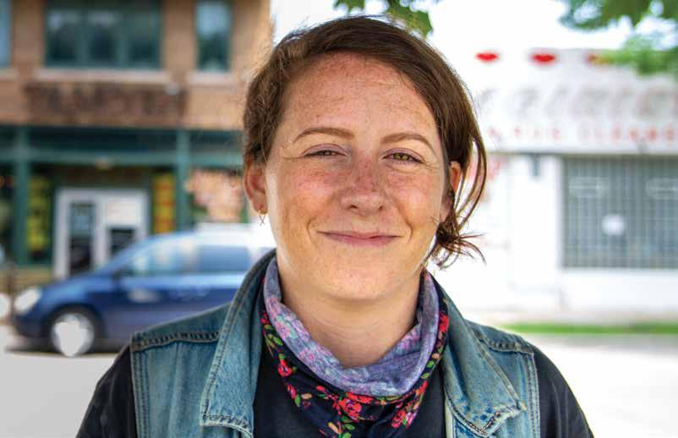
The Tandem’s Caitlin Cullen Fe...

Photo by Quinn Clark
The devastating succession of deaths of unarmed black persons at the hands of police officers, culminating with the murder of George Floyd in Minneapolis and the lethal shooting of Breonna Taylor in Louisville, along with the recent shooting of Jacob Blake in Kenosha, Wis., reflects something deeply and fundamentally wrong in America. By now, most Americans are aware of the numerous incidents in recent years and even know the names of many of the victims. Unfortunately, the issue is now being framed as a political choice to either support Black Lives Matter and the protesters or the police and law enforcement.

BY JAMES HALL
The long list of recent encounters has certainly resulted in a very wide array of protests, articles, removals of Confederate and other insensitive statues and monuments, donations to organizations and institutions promoting justice and equality, calls for reform of laws and policies, expressions of “wokeness” and similar actions. It is significant that there is a wide range of diverse people engaged in these actions at the local, national and global levels.
Many believe that the current period will prove to be a “watershed moment” resulting in the long overdue transformative change in our society to truly embrace justice and equality for African Americans. I believe there is still a question of whether the nation will undertake the necessary “reckoning” required for real change to occur in order to address the systemic racism that exists in American society. This is based on an examination of the nation’s history and the values upon which our culture has been built.

HISTORY OF POLICE CULTURE AND AFRICAN AMERICANS
The ideology of the inferiority of blacks has existed since the first Africans arrived in the Virginia colony in 1619. This ideology led to a racial caste system that viewed
blacks as subhuman. From the beginning, blacks were victims of kidnapping and torture, and laws provided that slaves could be killed for resisting their masters. Law enforcement, criminal laws and punishments were established with the intent to assist in the protection of whites and their property and the subjugation of blacks into a labor class benefiting whites.
This ideology was hardened both by the Supreme Court’s 1857 Dred Scott decision ruling that blacks were an enslaved race and not entitled to any rights bestowed by the Constitution, and the infamous 1896 Plessy v. Ferguson decision which enshrined racial segregation as constitutional and ushered in the period of Jim Crow and lynchings.
THE HISTORY OF THE CULTURE OF POLICING IN THIS COUNTRY ALSO TOO OFTEN INCLUDES AN AFFINITY BETWEEN LAW ENFORCEMENT AND WHITE SUPREMACIST GROUPS.
This history has not only fostered a view of black people as presumptively criminal, but it has also cultivated a tolerance for inhumane levels of brutality toward them in the name of law and order. America grew accustomed over the decades to witnessing the harsh punishment of blacks and a blatant disregard for protecting their rights or providing equal justice under law. This has been reflected not only in slave patrols, Black Codes and lynchings, but more recently in policies such as stop and frisk, mandatory minimum sentences, three-strike laws, children tried as adults, “broken windows” and qualified immunity.
From the beginning of the nation’s history through today, police forces in the United States have been the “tip of the spear” in maintaining the culture of white privilege, which generally has meant protecting whites and the privileged class from African American males who, as stated, have been characterized as thugs or criminals (formerly as savages or animals). There is a legitimate question of whether much-needed reforms to certain law enforcement policies—such as eliminating chokeholds and no-knock warrants, requiring cameras and limiting qualified immunity—will translate into changing the underlying police culture on the issue of race. This explains the calls by some for “defunding the police.” I do not believe anyone credibly advocates for a situation with no role for law enforcement. It might be better described as a need to re-envision and re-create law enforcement agencies from the ground up, which would include re-purposing them to protect and serve everyone, and not only white and privileged citizenry.

SPOTLIGHT ON KENOSHA
Kenosha is a city that is indicative of the problems and stark disparities that exist in many U.S. cities and metro areas. The economic and social disparity was exacerbated by the departure of Chrysler in 1988. There is a lack of jobs and opportunities for a large segment of the African American population. The economic disparity between whites and blacks in Kenosha is among the highest in the nation. As for law enforcement, only 3% of Kenosha’s police officers are black, compared to approximately 12% of its residents. With all of the focus on police shootings around the nation, Kenosha still had not purchased body cameras to be worn by its officers, although the City approved a measure to do so three years ago.
It seems that the message that had been communicated to Kenosha Police officers and the community prior to the shooting of Jacob Blake was the one consistent with the view of blacks as second-class citizens and comprising a social underclass. In 2018, Kenosha County Sheriff David Beth stated, referring to five people of color who he had called “garbage people”: “We need to build warehouses to put these people into it and lock them away for the rest of their lives… Let’s stop them from truly, at least some of these males, from going out and getting 10 other women pregnant and having small children.”
The history of the culture of policing in this country also too often includes an affinity between law enforcement and white supremacist groups. Perhaps this explains the reason why a young white man was allowed to roam freely on the street, assault weapon in hand, after shooting three people (killing two of them), even with people informing police that he was the shooter. That was distinctly different from the treatment received by Blake from police—seven bullets in his back. The community has called for an investigation of the relationship between both the Kenosha Police Department and the Kenosha County Sheriff’s Department and armed militia groups.

WHAT IS NECESSARY TO REFRAME OUR VALUES?
Violence and looting that have occurred in connection with some protests, which Black Lives Matter has disavowed as a part of the protesters’ agenda, cannot be condoned. It is typical that persons with other agendas that include violence or looting attend protests and create disruption. I submit that the best way to ensure that there is no violence or looting associated with protests is to eliminate the reasons for the protests in the first place.
If we are serious about addressing the problem of injustice and inequality, passing law enforcement reforms, while obviously necessary, will not be enough. It will also require American society taking ownership for the racism, acknowledging white privilege and its benefits and actually considering and embracing appropriate reparations to address the huge wealth disparity in this nation. As long as African Americans are regarded as second-class citizens, these disparities will likely continue.
I truly hope that the current protests and social justice movements will result in an outcome that embodies structural change and racial justice. To accomplish this, I believe we must get to the root of the problem - abolition of the existing culture of racism must occur and be replaced with reckoning, acknowledgment and programs of restorative justice and reparations.
James Hall is a leading Milwaukee attorney and litigator with a national reputation for representing plaintiffs in matters involving discrimination in employment, housing and education. He was a past president of the Milwaukee branch of the NAACP and served on the national board of the ACLU among his many civic contributions. He is also adjunct instructor and lecturer at UW-Milwaukee.

More stories from this publisher:
- from

